Sunday 12th September
Andrew Dearnley (ENG) opened the meeting by introducing GM Richard Hall (ENG) who welcomed everyone to Congress. In particular Richard mentioned the Lord Mayor of Leeds, notable honoured guests, and the members of the Congress Organising Committee.
The Lord Mayor replied welcoming everyone to Leeds and to Congress. She was presented with a bouquet of flowers by Andrew Dearnley.
Eric Ruch (FRA) made some introductory remarks. Eric invited the meeting to observe a minute’s silence in respect of those friends who have passed away since the previous Congress. Eric then declared the 62nd ICCF Congress open.
Congress was entertained by the Leeds Morris Dancers. Wonderful entertainment!
Eric Ruch presented a copy of ICCF Gold to the Mayor in thanking her for her attendance.
After a short break, the business of Congress began. The minutes of the 2008 Congress were approved.
Membership matters – Ecuador was readmitted to the ICCF.
Bertl von Massow Awards – Gold medal to Carlos Flores (ESP). Silver medals to Josef Mrkvicka (CZE), Artis Gaugens (LAT), J Franklin Campbell (USA), Carlos Cranbourne (ARG) and Tim Runting (AUS).
Other awards - World Championship 19 – Ivar Bern (NOR); Frank Gerhardt
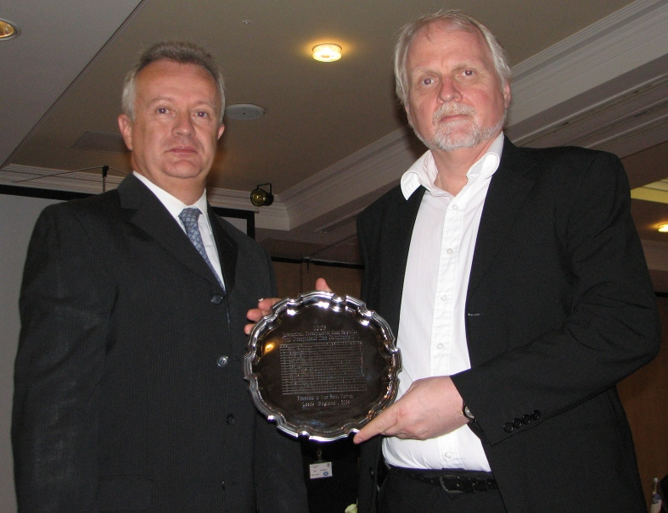
Norwegian delegate receiving the silver plate on behalf of Ivar Bern

Olympiad 15 – Norway (Gold).
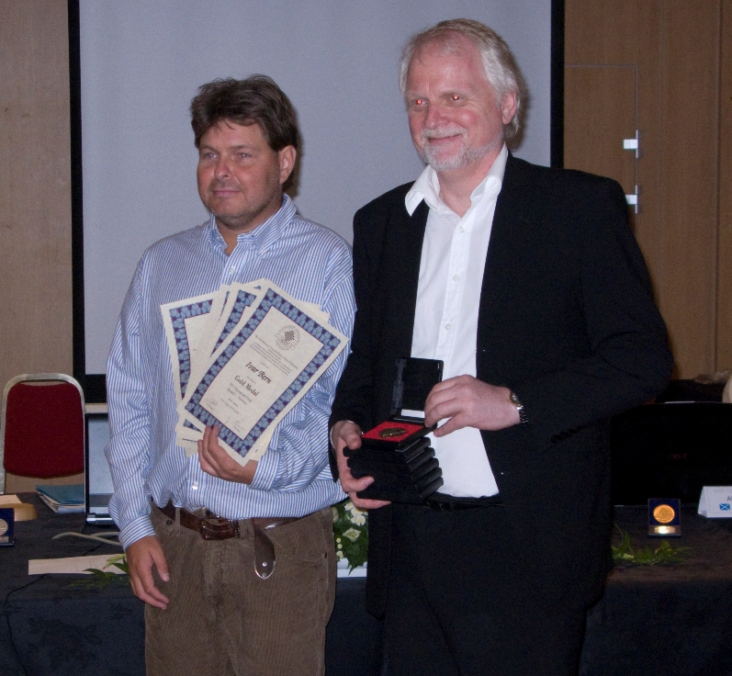
Boger, Lilleøren … Two of the two Norwegian players on the winning team …

Financial matters – The Finance Director who had resigned during the year presented the report. It was agreed that Germany should not pay fees for the Africa tournament. The Finance Director had resigned during the year because he had been outvoted by the Executive Board regarding the readmission of Chile who had previously been excluded. The Balance Sheet was accepted by Congress.
Auditor Report – The auditor (Alan Borwell (SCO)) reported a healthy balance and accurate presentation of the accounts. The accounts were adopted.
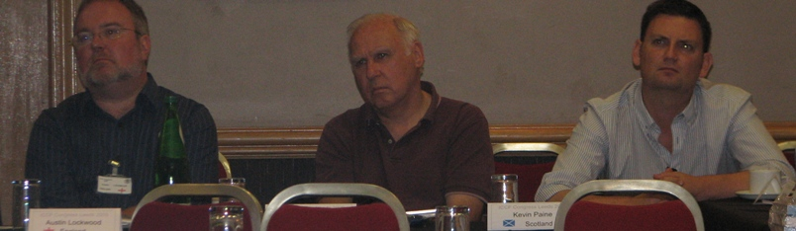
The UK bench! … Lockwood, Mackintosh and Paine
Election to Executive Board – Eric Ruch (FRA) was accepted as President by acclamation. Raymond Boger (NOR) was approved as Services Director by Congress. George Pyrich (SCO) was approved as Finance Director by Congress. There was only one nomination for the post of Marketing Director; he is Uwe Staroske (GER) who described his aims if elected to the post. Congress approved the appointment of Uwe Staroske by acclamation.


We also have time for some fun! … Boger, Peschardt, Millstone and Corky!

After lunch Congress discussed the World Championship cycle and the report of the Working Group on future World Championships presented by Gerhard Binder (GER). Gerhard presented a proposed new structure for the “World Championship Pyramid” followed by a set of proposals for Rules changes. After many questions by Delegates, it was agreed that qualifications will stand for a period of three years after the completion of the tournament. A set of proposals for temporary Regulations was also proposed.

Editor; Ian Pheby
Photo; Semrl, Langeveld and Boger
Editor; Boger

